(Approx. 678 words)

Microsoft’s New Emoji Keyboard
By Nancy DeMarte, Vice President, The Sarasota Technology User Group, FL
The STUG Monitor
www.thestug.org
vp1 (at) the stug.org

If you are an Apple user, you probably know about emojis. These little head icons express moods by the looks on their faces. They can be part of emails or text messages or any place where text can be typed. The emoji collection on my iPhone has over 100 faces, each with a recognizable facial expression, but the gallery goes way beyond faces. You can send emoji animals, objects, groups of people, plants and flowers, phases of the moon, food and drinks, sports, and many more.

The emoji was created by the Japanese. The term was formed from the combination of the Japanese words for “picture” and “character”. In Western countries, Emoji was originally called Pictograph. Emojis became so popular that a reference site, Emojipedia.org, was created in 2013. It is a search engine for emojis and is worth a visit. Emojis can be used in all the big social media sites like Facebook, Twitter, and YouTube, as well as email programs and other Internet places where you can type.

Microsoft has included a traditional on-screen keyboard (OSK) without emojis since the debut of Windows 7. Perhaps noticing the popularity of emojis, Microsoft created its own gallery of emojis and put them in an emoji on-screen keyboard. This keyboard was one of the feature updates Microsoft included with the Windows 10’s Fall 2017 Creator Update. It was improved in April 2018 and is now featured among the Ease of Access group of tools in Settings.

To use this keyboard, you are encouraged to enable it, but if you are current with Windows updates, you may be able to skip these steps. The enabling steps begin by clicking the Start button> Settings> Ease of Access. Then scroll down to Keyboard and drag the Off dot to the right under the heading, “Use your device without a physical keyboard.” Today, most users can easily open the emoji keyboard on their screens by pressing the Windows key while clicking the period or semi-colon key. This works for touch screens, too.
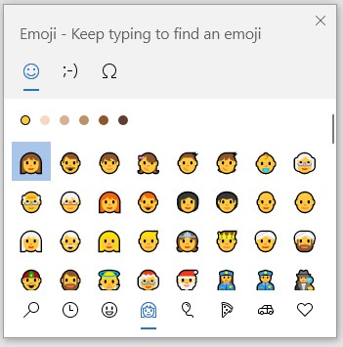
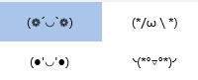
The keyboard contains three major categories along the top: Emoji, Kaomoji, and Symbols. The Emoji category includes the smiley faces and other objects like those seen in Apple products. Kaomoji includes facial expressions made of punctuation marks and other odd lines, some of which are Japanese. The Symbols category includes Latin symbols, international currency, the copyright mark, and others. Each category can be scrolled down for more choices.
four Kaomojis

Below are a few tips for using the Windows emoji keyboard:
1. To open the keyboard, click or touch the Windows key and the period or semi-colon.
2. Drag the emoji keyboard anywhere within the window.

3. To close the keyboard, click the X or the ESC key.

4. The magnifying glass symbol is a search engine for emojis.
5. The clock with hands set at 3:00 shows the most recently used emojis.
6. Emoji categories are pictured across the bottom of the keyboard.
7. There is a scroll bar on the Emoji keyboard, but it isn’t obvious. It is a short, thin vertical line on the right edge of the keyboard. See the red box around the scroll line in the illustration. Move your mouse over the line to enlarge the scrollbar and scroll for more emojis.

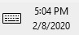
You can pin the emoji keyboard to the taskbar to make it larger and easier to see. First, right-click the taskbar and left-click the “Show touch keyboard” button. That will add a small keyboard next to the time and date at the right end of the taskbar, as shown. Click this keyboard to open the traditional on-screen keyboard which now includes the emoji icon. (Shown below) Click the face and scroll horizontally to see large versions of all the emojis for each category. (It too is a fine horizontal line below the emojis.)
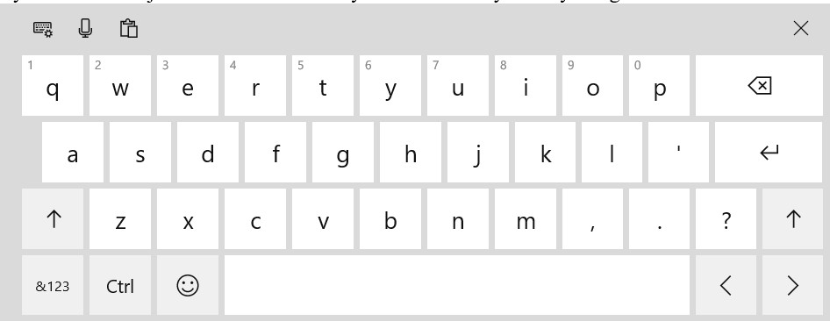

Then try out a few emojis on friends. They usually bring a smile.

